FOREWORD

Although some time ago (due to industrial action and the pandemic), at our last inspection in May 2017, the school received the highest rating from the Education and Training Inspectorate (ETI). It was said that our school…

“has a high capacity for sustained improvement in the interests of all the learners.”

This is a credit to all staff including teachers, assistants, supervisors, administrative as well as those who take care of our building and grounds. Together we will continue with our endeavours and keep on…

EDUCATING FOR TODAY AND TOMORROW

AG OILIÚINT D’INNIU AGUS D’AMÁRACH

In our school, we are all learners, from the Principal to the youngest child. We want to equip our pupils to make the most of their learning, not simply whilst they are in our care, but to fulfill their learning potential throughout the rest of their lives.
We are a Catholic school, embracing all who wish to join us as learners.

We aim to educate the whole child by providing a broad and balanced curriculum and by encouraging talent and aspiration.

We have been recognised for our work supporting children who have been born prematurely or who might be young for their year group with the ‘Tinylife Award’. This followed staff training, the submission of evidence and a validation exercise.

We are a ‘Digital School’ and have been awarded the Cyber Resilience Internet Safety Badge from DSA, (Digital Schools Award). This is an example of the high standards we work to for the children in our care.

As a school at the heart of the community it serves, we offer a well-established wraparound childcare service for children up to 5.00pm daily. This has come about through DE funding. Registered with social services, the most recent inspection was full of positive findings. Families greatly appreciate the quality service on offer at reasonable rates.

This prospectus gives a glimpse into life in St. John’s. To keep up to date have a look at our website at www.stjohnsswatragh.com

There is an APP linked to the website. This provides push button notifications about our calendar events. You can link straight to the website, access documents and much, much more from the convenience of your mobile phone.

CONTENTS

Foreword 1
Vision and Aims of St. Johns Primary School 3
Present Staff 4/5
Contact Details 5
Enrolments 6
Comments/Complaints 6
Bright Start Wraparound Childcare 6
Breakfast Club 6
School Uniform/School Meals 7
Accommodation 8
Health and Safety 9
Security 10
New Entrants 11
Safeguarding 12
Nurture in Education 13
House System 14
Anti-Bullying Policy 15
Special Education Needs 15
Attendance and Punctuality 16
Sickness and Absence 16
Homework 16
Irish Language 17
School Council 18
The Religious Education Programme 19
Charities 19

Information Technology 20
Music 21
Global Partnerships 22
PDMU 22
Eco Team 23
Trips and Outdoor Learning 23
Extra-Curricular Activities 24
Parents Support Group 25
Parental Involvement 26

Pupil Views 27
Safeguarding Flowcharts (Raising a Concern) Appendix 1
Admission Criteria 2024 Appendix 2

Vision for St. John’s
‘Educating for Today and Tomorrow’

Aims for Pupils:

St. John’s sets high expectations and develops learning for life by working with the children to:
- Develop morals and values, consistent with our Catholic ethos.
- Develop ICT skills to prepare for life-long learning.
- Achieve potential and experience success in a variety of contexts.
- Use and develop individual talents.
- Develop and learn to full potential.
- To respect themselves and each other and the environment
- Have confidence, independence, self-discipline and high self-esteem.
- Develop personal and social skills.

Mission for the school:
We believe that each child will be safeguarded and will succeed with our dedication and hard work through:
- A wide variety of activities implementing the broad and balanced curriculum for Northern Ireland
- A happy, safe, secure and stimulating environment
- Close links between home, school, parish and community
- A positive attitude towards health and fitness

We demonstrate our commitment to working as a learning community by:
- Striving for continuous improvement in all that we do
- Working collaboratively towards our shared vision
- Showing leadership in our areas of responsibility

PRINCIPAL ​
Mrs Fiona Kearney ​
School Management, i/c PDMU, PRSD, Assistant SENCO, Health and Safety, Gifted & Talented, RE Co-ordinator, School Council ​
​

VICE PRINCIPAL (3 days per week) ​
Mrs Karen McAllister -(Y4- Wed, Thurs, Fri): Assist Principal, SLG, Learning Support Co-ordinator, Staff Welfare.​
​

Ms. Una Logue Y1- Outdoor Learning, World Around Us, DDT​

Mrs. Eimear Kelly Y2- i/c Music and Productions
​
Mrs. McCullagh (Senior Leader)- Y3 Job Share (4 days Mon, Tues, Thurs, Fri) Numeracy and Assessment Co-ordinator (M Gráinne each Wed)​

Múinteoir Grainne Y4 (Mon and Tues)​ Girls’ Teams

Mrs. S. Kelly-Y5 World Around Us​

Mr Dermot McEldowney- Y6 ICT, PE + School Teams ​

Mrs. S. McNicholl Y7- (Senior Leader), DT, Accelerated Reader, First Aid, Literacy /UC Co-ordinator ​

Mrs. Claire Blaney- Learning Support Teacher + Nurture Education ​
​

Assistants:

Mrs. G. Smith, Mrs. J. Moore, Mrs. F. O’Hagan, Mrs. G. Crawford, Mrs. P. McLean, Mrs. D. Margey, Mrs. L. McGuckin, Mrs. C. Agnew, Mrs. A. O’Kane, Miss K. O’Neill, Ms R. Redmond

Ancillary Staff
Secretary Mrs Bernie McEldowney
Mrs. Lucy Kearney

Building Supervisor Mr. Barry Convery
Cleaners Mrs. Eileen McGuckin/ Ms. R. Redmond

Supervisory Staff Mrs. Eileen McGuckin
Mrs. Grainne Smith
Mrs Pamela McLean
Mrs Jackie Moore
Mrs Fiona O’Hagan
Miss A O’Kane
Mrs. G. Crawford
Mrs. L. McGuckin
Ms. R. Redmond

School Chaplain Rev. Fr. Charles Keaney

Contact Details
St. John’s Primary School
Tel: 028 79401623
E-mail: info@stjohnsps.swatragh.ni.sch.uk
Website www.stjohnsswatragh.com

CCMS 0289203014

SCHOOL DETAILS

Gate opens at 08.45 for bus pupils. Car drop off is between 08.50 and 09.00

10.00-10.45 Staggered breaks

11.55 – 1.05pm Staggered lunch times.

1.55-2.00 pm Y1 – Y2 Class ends

2.45pm Lessons end with the bus departing, then car pick up is from 14.50 to 15.00. Walkers leave at 15.00.

ENROLMENT

The enrolment for the school year 2023-24 is 225
The school is in a position of dealing with large numbers of applicants over recent years and The Board of Governors is working with CCMS and DENI to try to accommodate all those who wish to attend St. John’s.

APPOINTMENTS

The Principal is available to discuss any matters or concerns you may have. Please telephone to arrange an appointment.

COMPLAINTS

If you have a concern about school, it is a good idea to talk to the class teacher or the Principal. Appointments are easily made by telephone or by a message on the Class Dojo platform. A policy has been drawn up to inform parents of the best way to proceed and this is available on request or on the school website.



BRIGHT START WRAPAROUND CHILDCARE

This service aims to offer families wraparound childcare for their school aged children and provides peace of mind for many families knowing their children are cared for in a setting which is registered with social services and has an excellent staff ratio of 1 staff member to every 10 pupils. Hourly rates are competitive and include a healthy snack. Children are offered a wide range of games and activities both in and outdoors.

BREAKFAST CLUB

We offer a supervised Breakfast Club from 08.15 to 08.45 daily with a subscription of £2.50 which includes cereal and juice.

SCHOOL UNIFORM

The school uniform is universally adopted by all parents and is available to purchase in ‘Select Sportswear’ Magherafelt and J and M Clothing in Swatragh.

Uniform
Green half zip or sweatshirt with embroidered school crest
Green skinny tracksuit bottoms, or green shorts
White or bottle green polo–shirts
Trainers or shoes suitable for physical activity (easy fasten where possible).

In addition, there is the option of a green gingham dress, green skirt or pinafore.

The Class Councils, some time back, requested that we introduce a football jersey style top and the children designed it themselves. This now too is an option for uniform.

It is most important that all items of uniform should be labelled with the child’s name.
Please note that ballet pump style or other shoes where there is little support for the foot are not encouraged because of the difficulty of doing full physical activity in these.

SCHOOL MEALS
Meals are served fresh daily in the dining hall. A traditional set menu is offered each day. The menu is available on the website.
Pupils can alternatively, bring their packed lunch from home.

HEALTHY SNACKS
Our policy excludes sweets, crisps or fizzy drinks at any time. For break, pupils may bring from home scones and bread (not sandwiches), with fruit, vegetables, milk or water only.

NUT ALLERGIES
We are an ALLERGY AWARE SCHOOL AS we have pupils with severe nut allergies. For their protection, we respectfully ask that parents avoid sending nut products as part of snacks and packed lunches. This applies to food sent on school outings also.

ACCOMMODATION

Our accommodation comprises:

- 7 permanent classrooms
- Staff Room
- A multi purpose hall used for assemblies, PE, concerts and dining.
- 2 PE stores
- 2 Offices
- 2 sets of pupil toilets
- Male staff/ disabled toilet and Wet Room
- Female staff/ Disabled toilet
- Quiet Room
- 2 SEN rooms
- Library
- Resource room

In the school grounds:
- 3 main tarred areas
- Polytunnel
- Seating and Picnic Tables
- Bog Garden
- Playground Markings
- Quiet Area
- Outdoor Play Area
- 3G synthetic pitches
- Mud Kitchen Area
- Large sand grass pitch
- Cycle shelter and racks
- Staff car park at rear

HEALTH AND SAFETY

At St. John’s we promote the ideals of healthy eating. The effects of diet on health are taught to children at various stages throughout the curriculum and we promote healthy eating within the school environment. We ask families to avoid sending in fizzy drinks, crisps, sweets and chocolate bars and to comply with the policy for Healthy Breaks.
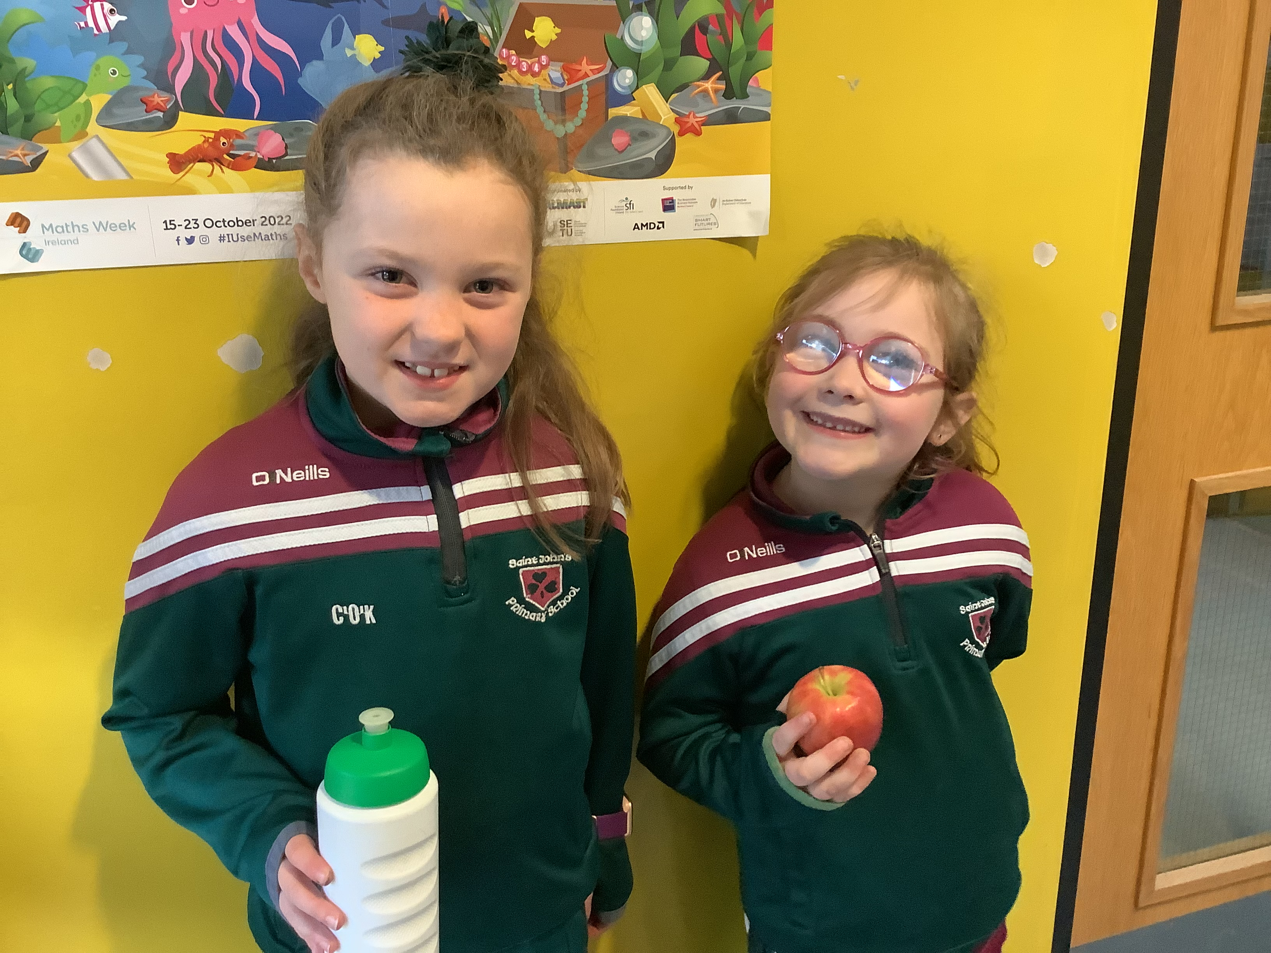

We aim to provide a safe, secure environment, which will encourage pupils to be health and safety conscious in and out of school.

Drugs Education

Our children receive a statutory Drugs Education Programme as part of their PDMU (Personal Development and Mutual Understanding). The Drugs Policy is available to parents, on request.

First Aid
First aid is administered, when necessary, in accordance with the Education Authority’s guidelines. Staff regularly undergo training in Epilepsy Awareness and the administration of Emergency Medication as appropriate. Teachers have updated training in administering the Epipen for severe allergic reactions. Our First Aiders are B. Convery (Building Supervisor), Mrs. S. McNicholl (Y7 teacher) and G. Crawford (Classroom Assistant)

Road Safety Curriculum
We play a vital part in educating our children for life, in Road Safety issues. We place the child at the centre of our programme. We work with parents and the wider community to continually improve safety as evidenced in our SUSTRANS programme.

SECURITY

School is kept secure throughout the day by the application of restricted access. Visitors should press the gate buzzer for attention.

Advice is provided by the EA.
School is open to pupils from 08.45 daily or for Breakfast Club children from 08.15.

DROPPING OFF
Staggered times are in place to ease traffic congestion at the DOE layby on the busy A29.

If pupils need to leave school early to attend an appointment or because of sickness, then parents must collect them from inside the school building. Please notify the school Secretary or Principal about the child’s departure, so that attendance records may be accurately maintained for legal and safety reasons.
The Secretary has a CCTV view of the front door and can admit authorised personnel electronically.

COLLECTION AT HOME TIME
Teachers of pupil in Y1 and Y2 (as well as Y3 until they stay in until 3.00pm), will accompany pupils to the front gate where parents will collect them.
Pupils in Y3 to Y7 will walk to the front yard to line up in groups for buses, walking home and for those being collected by car. These pupils will be supervised by the Duty Teacher.

EVACUATION
In the case of a fire or other emergency, there is a written Evacuation Policy for staff to follow. All pupils know what to do when the fire alarm sounds as there are frequent, regular fire drills.

NEW ENTRANTS-YEAR 1
Most children now attend pre-school facilities and this very often helps effective transition to school. They get to know other children who will be in their Year 1 class. In their first year, these children must get used to a more formal setting and it does take them a while to get used to new routines for playing and learning.

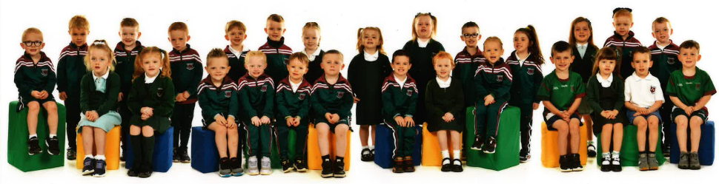
To help new entrants and parents adapt to Primary School life we have a Parent Information Evening in May and an Open Morning in June. This provides an opportunity for pupils and parents to see something of the school and the Year 1 teacher, Mrs Logue, along with the classroom assistant and they can also see into the classrooms.

Your child will be made most welcome here in St. John’s Primary School. As a staff we will endeavour to make your child’s time with us both happy and rewarding.

We offer each new entrant, ‘a space where they are accepted as the unique individuals they are, in an atmosphere of warmth and love’. By the end of Year 1 the children have come to an awareness of the presence of God in their lives and the lives of others, through nature and the people we come in contact with.

SAFEGUARDING POLICY
Our Safeguarding Policy is regularly updated. We have a focus on On-line Safety, Anti Bullying, Positive Behaviour and Child Protection and a copy is available to every family. We in St. John’s Primary School fulfil the aims of the Northern Ireland Curriculum Order which is to empower young people to develop their potential and to make informed and responsible choices and decisions throughout their lives. Families and pupils are consulted about the policy.

Our policies comply with ‘Welfare and Protection of Pupils Education and Libraries (NI) Order and all current DENI guidelines and considers that the welfare of each child in our care is paramount. Safeguarding is included as an integral part of the School’s Curriculum.
We aim to encourage all children towards a positive self-image, which will equip them to make reasonable informed choices and so acquire the fundamental principles of personal safety.
In school we maintain and update Safeguarding practices evaluated in line with the ETI pro-forma so that all school staff know how to act if they have concerns or need support regarding a particular child.
Teaching, Support Staff and Governors have undergone training in Child Protection. All staff and tutors are vetted according to DENI guidelines.
The Designated Teacher for Child Protection is Mrs. McNicholl.
The Deputy Designated Teacher is Ms Logue.
If you have a concern about a child, procedures are outlined in our policy available from the office or on the school website.

The Pastoral and Nurture in Education approaches, permeate all activities within the school through the caring commitment of all our teachers to help pupils:

- Develop morals and values, consistent with our Catholic ethos.
- Achieve potential and experience success in a variety of contexts.
- Use and develop individual talents.
- To respect themselves and each other and the environment
- Have confidence, independence, self-discipline and high self- esteem.
- Develop personal and social skills.
Our school mission states that we believe that ‘each child will be safeguarded and will succeed with our dedication and hard work through…
- A happy, safe, secure and stimulating environment
- Close links between home, school, parish and community
- A positive attitude towards health (including mental health) and fitness.
NURTURE IN EDUCATION
As far back as 2018, we have been promoting whole school nurturing approaches, we have implemented a range of effective strategies to ensure the well-being of children and their readiness to learn.

Neuronimo Programme
The Neuronimo programme is a whole school experience. Based on evidence from the University of Ulster and the University of Southampton, the 12-week online programme helped children to reflect on their mental and physical health, make positive choices and explore regulation activities. There was also an opportunity for pupils to engage in these activities at home.

REACH Programme (Resilience Education Assisting Change to Happen)
Children from Year 4 to Year 7 have participated in EA’s REACH programme with a focus on whole class and small group activities. Pupils engaged in discussions, art and creative activities linked to regulating their emotions, friendship, transitions and the “Take 5 Steps to Well-Being”. This was subject to inspection by ETI. Mr. Peter Dennis (District Inspector), commended staff involved for the integration of approaches and was most praising of our pupils who were well able to articulate their enjoyment, understanding and the impact of the programme.

Trauma and Attachment Informed Spaces within the Education Environment
This initiative from the “Children Looked After Education Project” team was designed to help schools to create a trauma and attachment informed space within their setting. The aim was to provide a space that supported children with their sensory processing and emotional regulation. We created a Calm Den within our school library, incorporating a range of recommended tactile, proprioceptive and vestibular resources. Our Well-Being Ambassadors helped to decorate our Calm Den and they also contributed their opinions about how the space could be used most effectively.

Children’s Mental Health Week
We celebrate Children’s Mental Health Week in February. This year's theme was “Growing Together” and children were encouraged to reflect on ways that they had grown, changed and learnt new things. They also reflected on who had helped them along this journey and how they had helped others.

Healthy Happy Minds Project – Play Therapist
Using funding from the Healthy Happy Minds project we secured the services of an Action Mental Health Play Therapist. This provision supports children who may be experiencing bereavement, anxiety, challenges with emotional regulation or will benefit from increased self-confidence and resilience. Counselling takes place on a 1-1 basis and will continue into the 2022/2023 academic year.

Motivation for pupils is something we continue to work on. To that end we have monthly competitions for ‘Writer of the Month’ and we have ‘Numeracy Champs’ reported in each newsletter for parents to see.

We continue our work on well-being with a focus on information and resources to support pupils’ wellbeing and framed by:
- Six Principles of Nurture
- Five Levers from “A Recovery Curriculum: Loss and Life for our Children and Schools Post Pandemic”

We are commencing a new project with the Education Authority: ‘Being Well, Doing Well’. This will include updated staff training and refreshed whole-school approaches.

HOUSE SYSTEM REWARDING GOOD MANNERS AND ATTITUDES

We have a system of dividing the children into 4 ‘houses’ named after the four provinces of Ireland. Staff have 20 reward points available to issue throughout the week. Cleaners, assistants and teachers recognise good manners, behaviour and helpfulness by the allocation of a point for the child’s ‘house’. Each week the points are tallied and a graph showing the children how they have done is displayed on the ‘House’ board. Each half term, credit is also given for full attendance and the winning House has a treat.
Feedback from pupils and staff has shown the system to be motivational and effective.



ANTI-BULLYING POLICY
St. John’s Anti-Bullying Policy is regularly reviewed and is line with latest legislation as well as guidance from the NIABF (Northern Ireland Anti-Bullying Forum). It aims to prevent any bullying/aggressive behaviour by sustaining a pleasant, friendly and caring environment within the school to promote respect for the individual and encourage trust and openness. We ask pupils to consider this question…
DO YOU DISPLAY BULLYING BEHAVIOUR?
DO YOU MAKE ANYONE FEEL UNHAPPY?
Positive Behaviour Strategies are used to enhance good discipline.

SPECIAL EDUCATIONAL NEEDS
In St. John’s Primary School, we aim to provide a broad, balanced, relevant and differentiated education as a right for all.
We promote the integration of all pupils with Special Educational Needs as far as is reasonably practical, into the life and work of the school.
A child who has Special Educational Needs will have Special Educational provision made for him/her in line with the current Code of Practice.

In addition to those children with an identified Special Educational Need, there will be many pupils at varying times throughout their time in Primary School, who experience challenge in their learning and may have particular barriers to learning with which they need help to overcome.

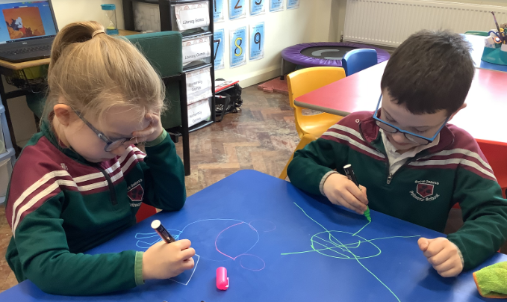
In St. John’s we have a very varied
range of provision to help pupils at
these times. This includes completion,
by the class teacher, of individual
Personalised Learning Plans.
We have the benefit of a part-time
Learning Support Teacher providing
targeted interventions. Work is
assessed and recorded so that each
pupil’s performance can be monitored.

There is additional support provided by Classroom Assistants. We develop and utilise all available resources in support of pupils with learning needs.
In addition, there is a policy and strategies in place to provide for the needs of very able pupils.
In school we work closely with health professionals from RISE (Regional Integrated Support for Education) as well as with other external agencies who can help support physical or learning disabilities. We have several children with a Statement of Educational Need who are supported by a dedicated assistant each.

ATTENDANCE AND PUNCTUALITY

Attendance rates for the school had traditionally very high. Like many other schools, attendance dipped following Covid but figures have been on the increase sine that time. Last year the school attendance was 95.6% which is still slightly down on the years prior to Covid. This may well be due to caution by parents, as a result of the pandemic. However, we should be aware that the average primary school attendance across all six counties, was 91.6% and we are happy to have a favourable comparison.

We pride ourselves on a having a happy and welcoming school which children are keen to get up for every day.
Those pupils with full attendance are recognised and awarded certificates on Prize Day.

SICKNESS AND ABSENCE

If your child is sick, please telephone the school so that accurate records can be maintained. It is a safety issue as well. If your child leaves to come to school but does not arrive, our procedures mean early alerts can be raised.

All pupils who attend school are expected to come equipped to go outside even in cold weather. If your child is well enough to attend, they are considered well enough to take part in all activities including outdoor learning, play and physical activity. If a doctor directs no physical activity, please contact the school explaining this.

HOMEWORK

In Saint John’s we believe that homework is of great benefit to pupil learning. It allows for some practice and reinforcement, of what has been learnt in class. It also provides an opportunity for parents to talk to their child about
lessons and to support and encourage the child’s efforts. If homework cannot be completed there should be no anxiety. Our homework approaches encourage self-discipline and independence. Each class teacher outlines expectations at the start of the year. Samples of work are uploaded for teachers to see success and where further support might be required with a particular topic.

IRISH LANGUAGE

Many of our pupils come from the local Irish language pre-school and it is our sincere and strong desire to continue to pursue the planning and establishment of an Irish Medium Unit and we are currently working with the support of CCMS to that end.

Pupils and staff engage in incidental learning of useful phrases. We are involved in the SCOIL SPREAGTHA.
This accredited scheme aims to celebrate and encourage efforts made by English-medium schools to encourage the use of Irish in the school environment. ‘Scoil Spreagtha’ in its design aims to inspire schools to showcase and/or expand their efforts to promote the use of our indigenous language in the school setting.

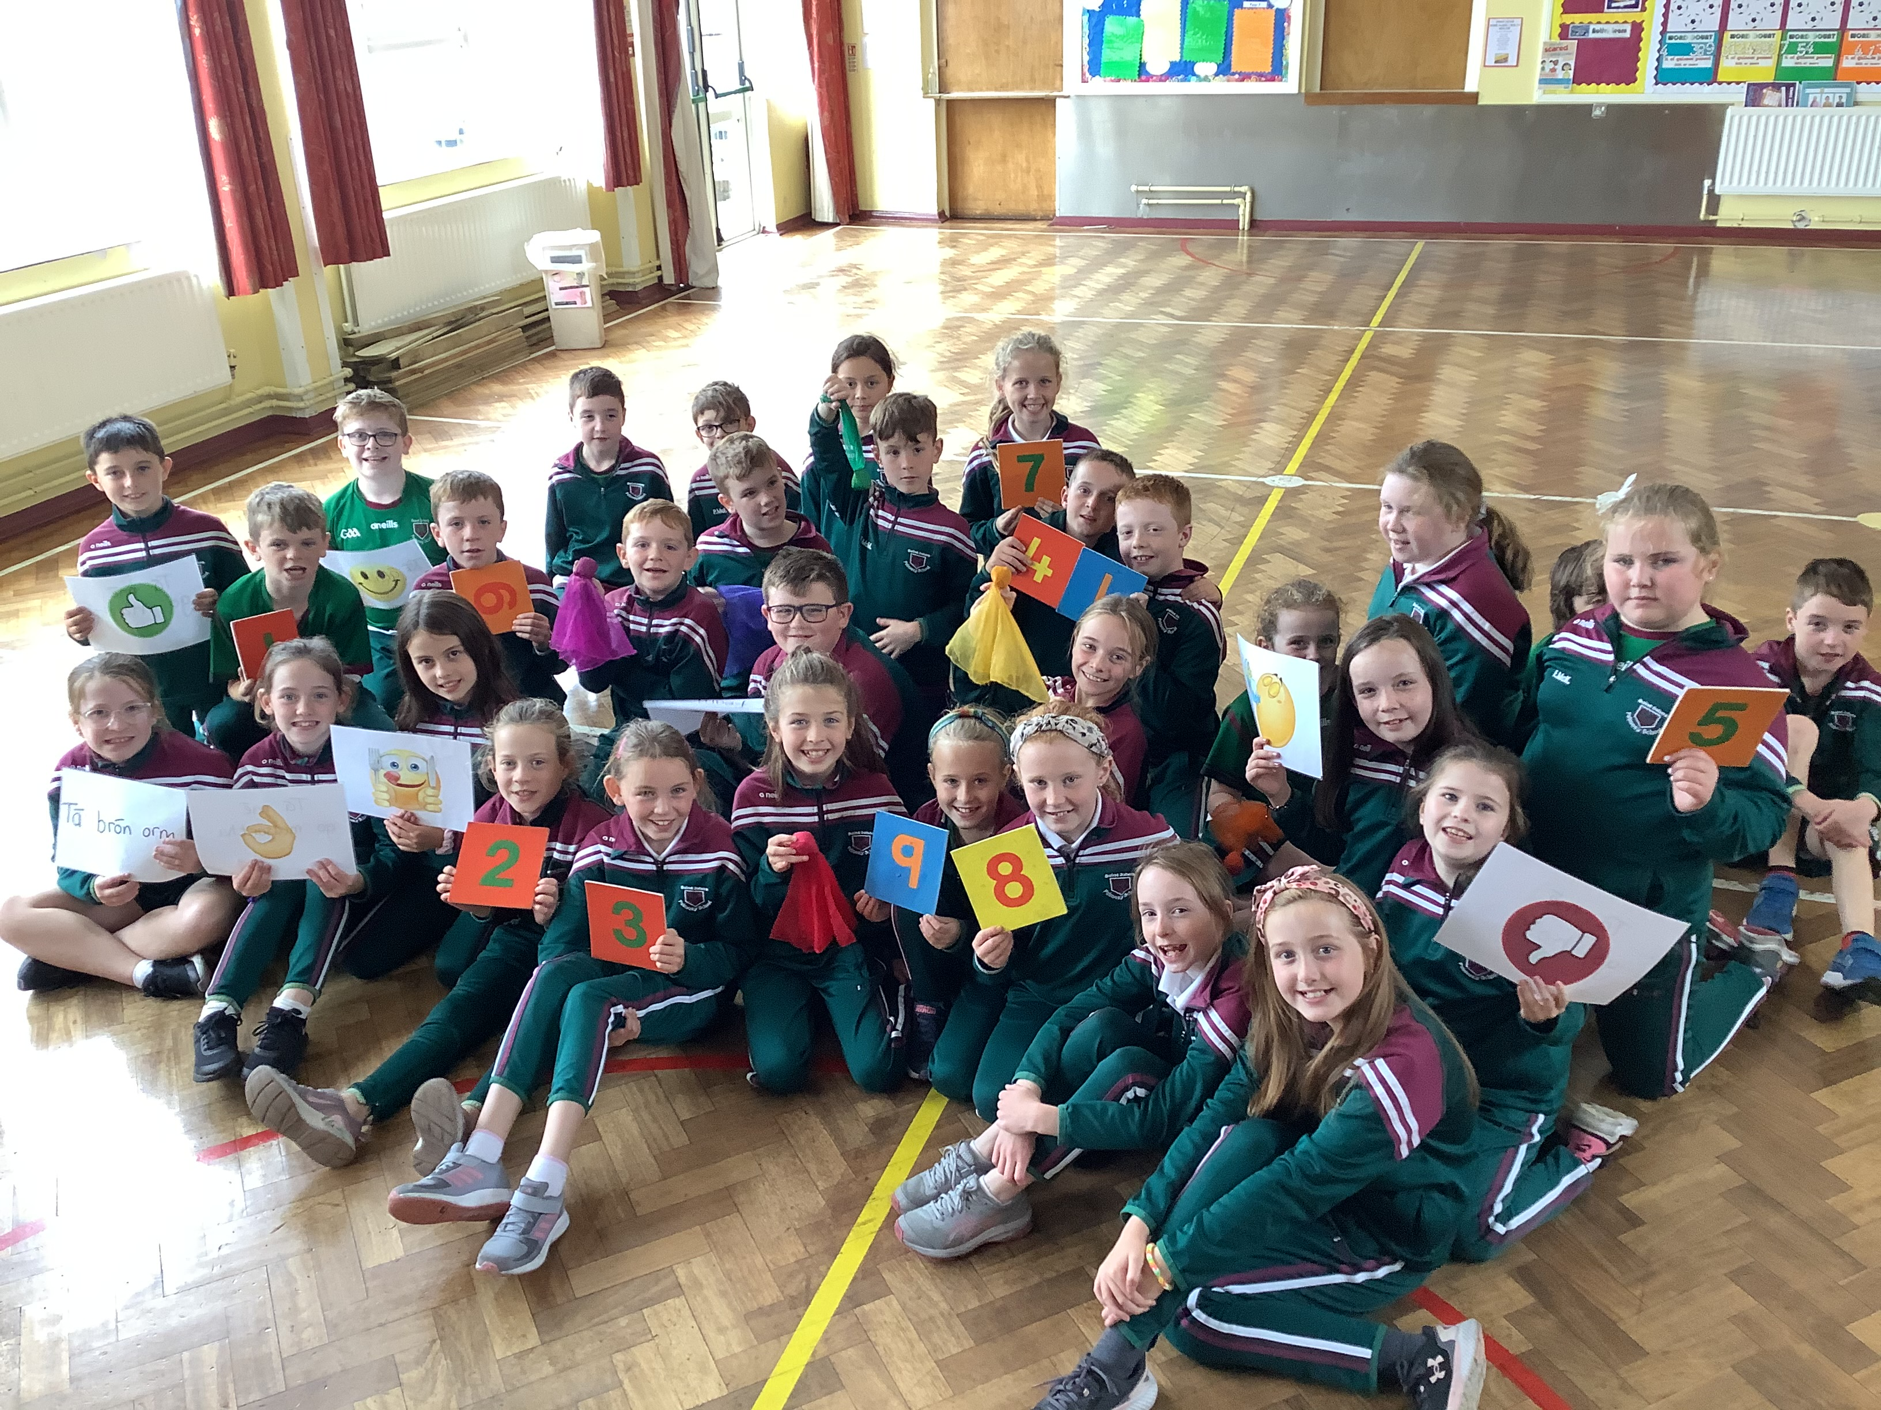

SCHOOL COUNCIL

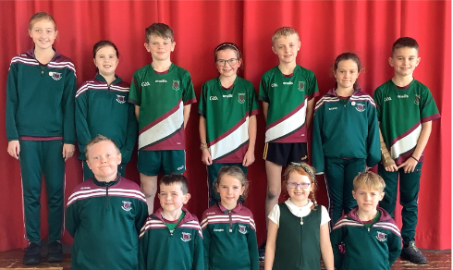

Pupils have a voice in the running of the school through representation on the
School Council. Pupils from Year 3 to Y7 elect a number of children from their class to convey year group views to the Principal and SLG and to make suggestions and plans for improving daily life at the school. Our Y5 Assistant, Orlalee meets the Council regularly and they have organised a very successful Shoebox Appeal to support homeless people in Belfast.
Their other work to date includes helping with ordering outside games and equipment, eco issues, organising and choosing the playground markings and more. They make suggestions about the dinner rota and resources for the classroom.
We feel such inclusion in the decision-making processes in the school, gives pupils a sense of ownership and belonging, which leads to increased respect, responsibility and better behaviour.

THE RELIGIOUS EDUCATION PROGRAMME

Our Religious Education programme is based on the Children of God series ‘Grow in Love’ and prepares each child for participation in the liturgy and sacraments of the Catholic Church. Religious Education is not confined to the timetabled programme within the school but pervades the whole life of the school.

We see the school as a vital part of the Granaghan parish and take every opportunity to contribute to the life of the parish. To do this, we liaise closely with our local priest Fr. Keaney. Children in Y3 to Y7 attend Mass on a rota basis each Monday.
We have school Masses at the start and end of the year and the parents and local community are invited to these.
Year 3 acts out a Nativity Play in the chapel. Fr. Keaney visits the school regularly, playing a full and active role in the life of the school. Year 7 take part in the Liturgy, in preparation for the Sacrament of Confirmation.

Should any family prefer their child not to participate in collective worship, then suitable arrangements can be put into place through mutual agreement.

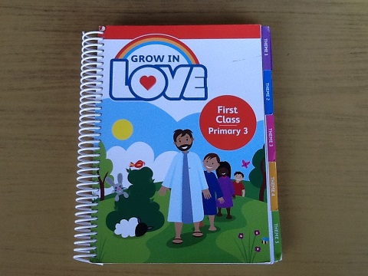

CHARITIES
In St. John’s we try to help others by raising money for charities.
In the past we have supported…
- Shoebox Appeal
- School Aid Romania
- Maghera Food Bank
- Ukraine

INFORMATION COMMUNICATION TECHNOLOGY (ICT)

Through the support of parents and local businesses, we have been able to augment our ICT hardware for pupils with the introduction of Surface SE laptops. This has enhanced the delivery of lessons for our USA project link through the JDO Foundation, the use of BBC Microbits and lots of other Coding games along with many cross-curricular classroom topics.

We were delighted to be awarded the DIGITAL SCHOOL CYBER RESILIENCE AND INTERNET SAFETY BADGE as a result of a rigorous evaluation process, culminating in a virtual interview by the assessor who spoke to staff and pupils, following the examination of a wide range of documentary evidence. Staff have aimed to maintain very good standards in using ICT to support learning across the curriculum. Tablet technology continues to be used, to ensure pupils have the optimum opportunities to develop their skills.

Children can do Maths homework using tools like Timetables Rock Stars, play educational games with Heinemann Active Learn and in addition, parents can see how their child is progressing with their levels in our Accelerated Reader programmes, all accessible online once given the school links.

Class DOJO is an effective tool in motivating pupils’ positive behaviour and as a way of keeping in close communication with parents on a daily or weekly basis.

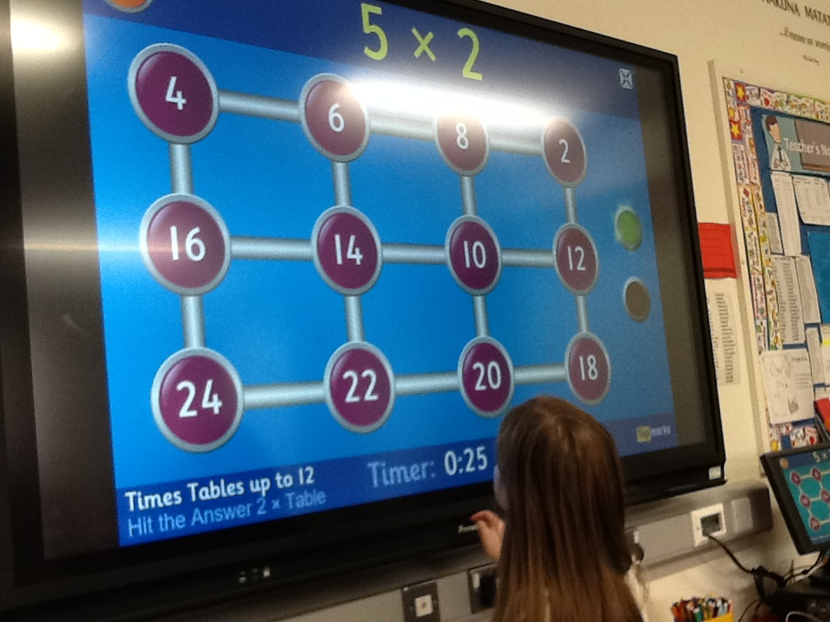

Digital Leaders

Pupils are selected in each class Y3 to Y7, to take responsibility for ICT issues like preparing equipment and resources, setting up, logging in and providing alerts when needed, in addition to providing their much-needed advice and tips.
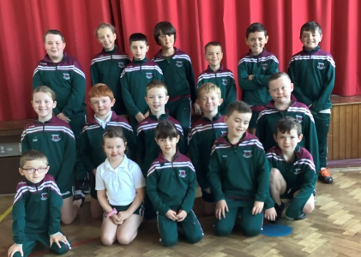

MUSIC

Music is timetabled as part of the school’s daily curriculum. In St. John’s we aim to develop the child aesthetically and in promoting music we are doing so.

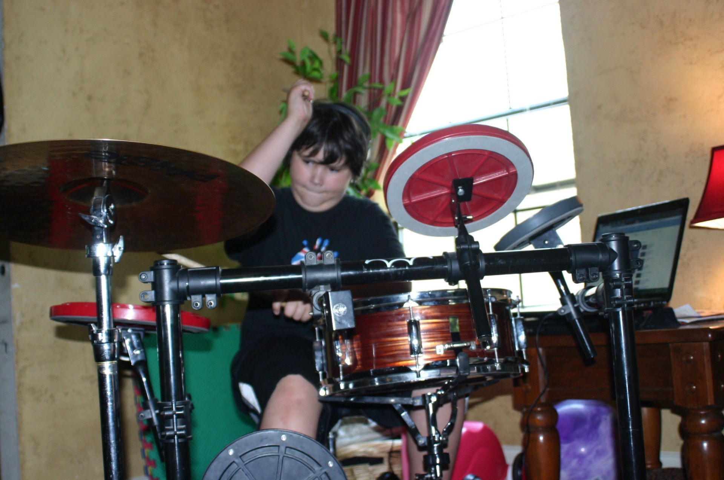

School Choir
When in operation, the school choir is selected from Year 3 – Year 7. They performed regularly for school-based events such as Confirmation, First Holy Communion, Assemblies, Carol Services etc. Some children have taken part in Ecumenical Services and Fesieanna.

Instrumental Music
Many children receive weekly tuition in the violin and flute from the EA’s peripatetic music service. Lessons take place once a week and they perform together at special events throughout the year.
In addition, we have weekly drumming tuition from a qualified tutor and this is a huge hit with the pupils.

Productions

Last year, the pupils in KS2 performed ‘Pirates Versus Mermaids’ to great acclaim and with thanks to our Musical Director, Mrs. Kelly and all the KS2 staff.

GLOBAL PARTNERSHIP

For a long number of years, the school has successfully
applied for funding for a series of Erasmus projects which
have linked us with primary schools in Greece, Germany,
Turkey, Italy. Cyprus, Spain, Romania, Poland, Finland
and Hungary. The work of these projects helped to provide
professional development opportunities for staff and
supports our policy of promoting pupil understanding of
international issues.

PERSONAL DEVELOPMENT AND MUTUAL UNDERSTANDING (PDMU)

For many years the school has stretched hands across the divide by participation in a variety of cross community links. There had been a long-standing partnership with Eden P.S., which ended and this has been followed by less formal links with Ampertaine P.S. and the local Bible Society in Garvagh.
Learning about, and having respect for others, is a central theme in our work as a Catholic school and in teaching pupils about citizenship.

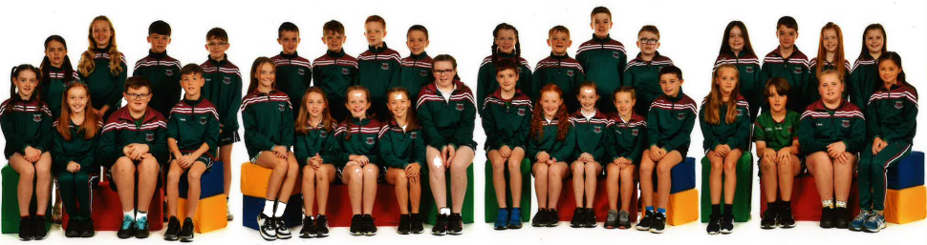
Year 7

ECO TEAM

St John’s ECO Team ordinarily consists of pupils from Year 3 to Year 7, staff and parent representatives. The team meets and regularly discusses how our school can become more environmentally friendly by turning off unused electrical items and reminding everyone of the message to reduce, reuse and recycle. Our school has also achieved ‘Green Flag’ status and we continue to work towards renewal with Mrs. S. Kelly at the helm.
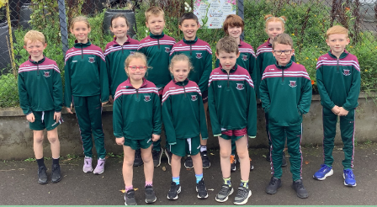

Trips and Outdoor Learning
We have been part of an EA Pilot scheme to promote Outdoor Learning. In Saint John’s we believe in bringing learning outside of the classroom to help the pupils’ development. All classes have opportunities for educational visits which may include the library, the Knockoneil River, a salmon hatchery and the local NCCE.
In Y7 pupils have the opportunity to go on a residential which is educational and which will promote social development in a way, which would not be possible in the classroom. These trips are financed by voluntary subscriptions from the parents, from pupil savings and are sometimes subsidised by special funds or outside grants. Parental permission is always required for such events.
.
The Outdoor Play Area and Mud Kitchen was financed by donations and fundraising by parents and has been physically upgraded by volunteer parents. Children use it in a way integrated into planned teaching and learning for physical and imaginative development, as well as aiding language and maths skills. Of course, they enjoy it at break and lunchtime too!

We have recycled BATHS around the school where children from each class
plant a vegetable or flowers and learn about the growth cycle as well as healthy eating. The Eco Team ensure the baths are maintained all year round and it is not an
easy task! With a generous grant from DAERA we have been able to erect a polytunnel to advance pupil learning in this area.
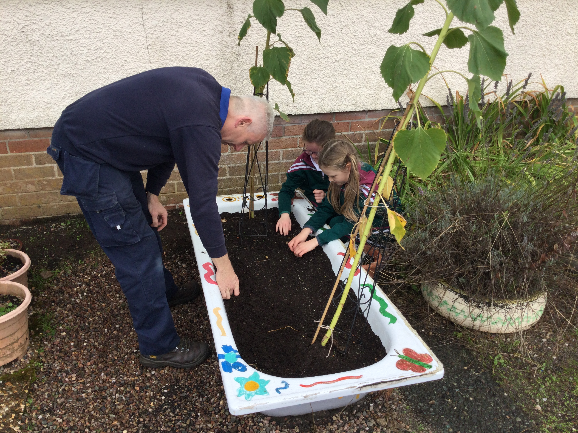
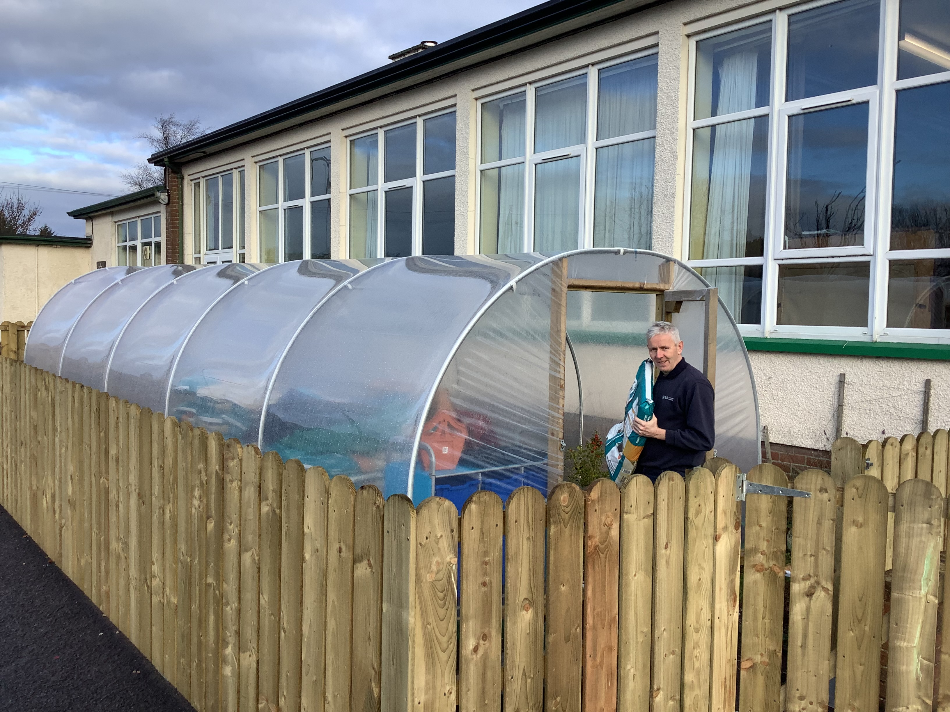

Outdoor learning is greatly enhanced by our extensive playing fields and 3G pitch.
Pupils make excellent use of the pitches at break and dinner, as well as having much better scope for PE lessons and training after school.
The pitches are available for hire to community groups.

EXTRA-CURRICULAR ACTIVITIES

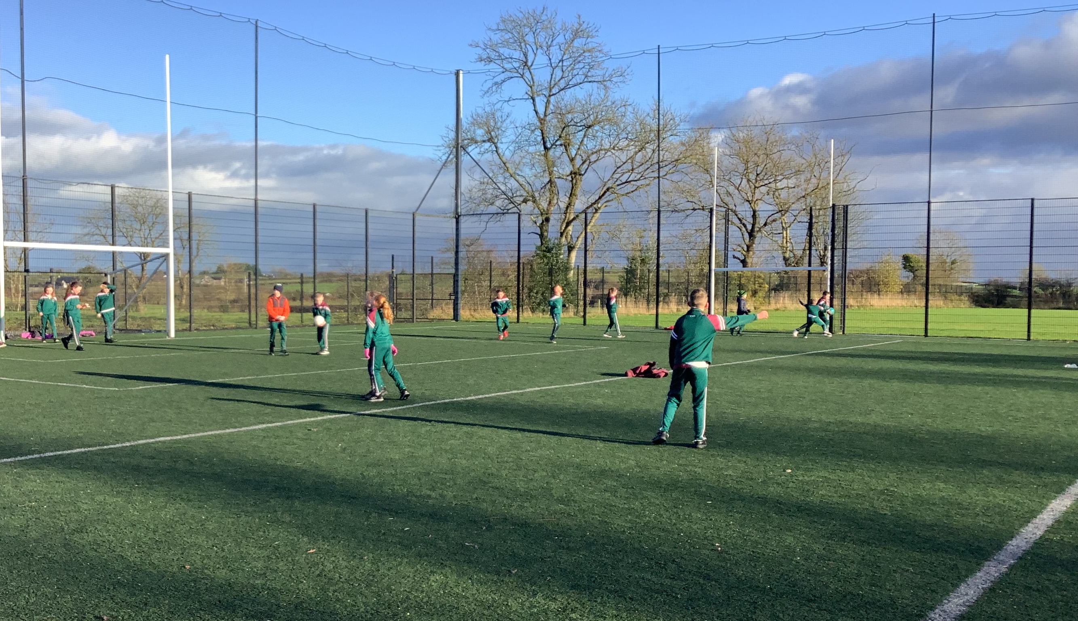

Gaelic Games

The school is involved in the South Derry Primary Schools League and is also a member of Doire Cumann na mBunscol, which promotes Gaelic Games throughout the county. All children receive coaching in Gaelic and hurling skills from the Ulster Council.

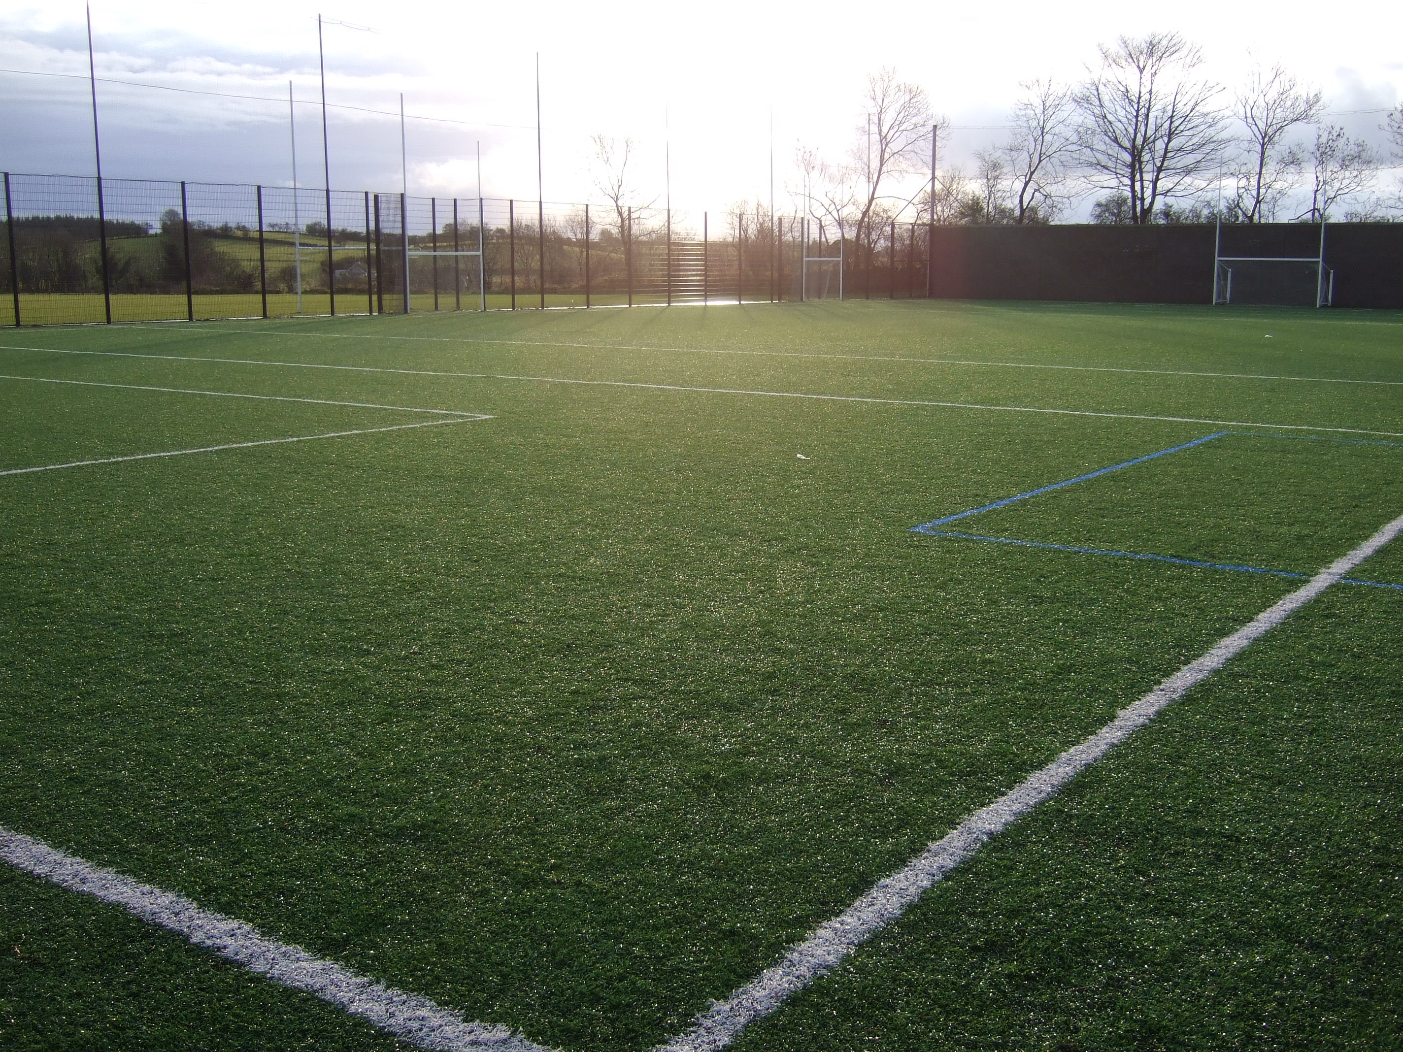

Cycling
Each child is encouraged to participate in the Cycling Proficiency Scheme before leaving Primary School.
Tuition is provided after school for Year 7 pupils during the spring/summer term.

Public Speaking
Pupils often have the opportunity participate in Public Speaking competitions, for example, those organised by the Magherafelt and District Road Safety Committee and in the Environmental Youthspeak competition organised by Mid-Ulster Council.

Scór na bPaistí + Feis Carntogher

Pupils are given the opportunity to enter these competitions from time to time. Children enter the Feis art competition as well as singing, instrumental music, recitation and the quiz. They have the choice of being prepared in English and /or Irish for the recitation and their success has been impressive.

PARENTS’ SUPPORT GROUP
We highly value the role of parents in the educational partnership between school and home. The PSG works to raise money for school funds for the purchase of additional resources and to organise many school events, to accompany trips, assist staff or take part in consultations and research. This extra help enables the children at our school to receive the best possible education that can be provided.

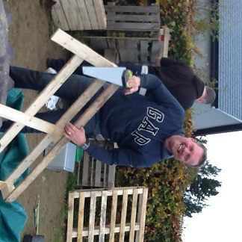
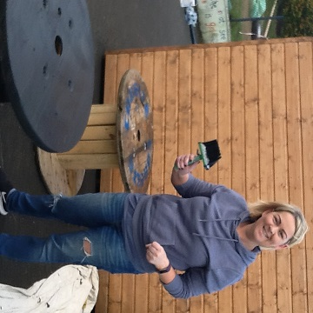

Over the years, many thousands of pounds have been raised.
Throughout the school year, fund raising events are organised for example, the Halloween Sponsored Walk, Christmas Quiz and various raffles. We are always encouraging more parents to join and any new members will be made most welcome.
The following staff members help the group also: Lee McGuckin, Mrs. McCullagh and Mrs McNicholl.

PARENTAL INVOLVEMENT

St. John’s Primary School seeks to involve parents fully in the education of their children. The school enables parents to keep in touch with the progress of their child through:

- An open-door policy for parents to arrange meetings with teachers/principal to discuss the progress of their child.
- An annual parent-teacher meeting which focuses on academic progress.
- The publication of the Annual Report by the Board of Governors
- An annual pupil report.
- Participation in a pupil self-evaluation process
- The Parent Support Group
- Prayer Services/School Mass and Assemblies
- Monthly Newsletter
- Open access to the school’s policy documents.
- After School provision
- A formal complaints procedure.
- Parent Charter
- Regular consultation exercises.

Here is the Parent Charter as devised by parents themselves.

As parents of children in Saint John’s, we have the right to…
- Be treated with respect by teachers, pupils and Governors.
- Have our views heard.
- Be informed about the process of learning for our children.
- Know about my child’s progress through written reports and teacher meetings.
- Share ideas through the Suggestion Box or by talking to the Principal.
- Have access to all Policies, the Annual Report and the Prospectus
- Be involved in the child’s school life: Attend events like assemblies, prayer services and many more.
- Join the Parent Support Group
- Contribute to funding, fund raisers and to the donations of materials and services.
- Help in lessons at the invitation of the teachers.
- Be represented in the school management.
- Work with the school to fulfil the Mission Statement…

‘Educating for Today and Tomorrow’.

This is what our pupils think of St. John’s

“St John’s is a fun place where I feel safe”. “I love getting outside to the 3G pitch to play with my friends”. (Lucia Y7)

“The grown ups always take care of you and I really enjoy meeting with friends every day from my class”. (Fionn Y7)

“The ICT is great and I enjoy the online learning, we are very lucky to have lots of new laptops in our class.”(Daire Y7)

We are very lucky to have football, hurling/camogie and swimming available at this school. This helps us develop our P.E. skills. (Annie, Y5)

We are an Eco friendly school, we have a polytunnel to grow fruit, vegetables and flowers. We also have chickens that we collect eggs from. We have lots of outdoor learning in our school. (Emma Rose Y5)

Our staff are lovely and friendly and always help us out. (Dearbhla, Y5)

I love all the different instruments that we have a chance to learn such as drumming. The choir is good fun to be a part of. (Darragh, Y5)

The teachers are very nice to all the students here. They make learning fun and exciting. I always feel safe here and if I’m scared there’s always an adult I can turn to. (Aisling Y6)

I love St. John’s because we get to do lots of Art and go outside. (Sarah Y6)

I love all the sports at St. John’s If you can’t do something, the coaches will help you. They are all fair and no-one gets hurt. (Aoife M Y6)

I love St. John’s because when you walk in the gate there is always a teacher to greet you!
The teachers turn your frown upside down. If you are having a bad day, they sort it out.
We have learning buddies in Y1 and Y5! (Aoife B Y6)

APPENDIX 1
SAFEGUARDING FLOWCHART

How a parent / carer can raise a Safeguarding Concern

I have a concern about my / a child’s safety

I can talk to the class teacher

If I am still concerned, I can talk to the Designated Teacher (Mrs. McNicholl) or the Deputy Designated Teacher (Mrs. Coyle).

If I am still concerned, I can talk or write to the Vice-Chair of Governors, Mr. Paul Kearney

If I am still concerned, I can contact the Public Services Ombudsman
0800 343 424

At any time, I can talk to the local Children’s Services Gateway Team or the PSNI Central Referral Unit
02890259299

St John’s Primary School  30 Moneysharvin Road  Swatragh  Maghera  BT46 5PY  Telephone No: (028) 7940 1623  Email: info@stjohnsps.swatragh.ni.sch.uk  Website: www.stjohnsswatragh.com | Maintained Primary School  Enrolment Number: 195  Admissions Number: 28  PRINCIPAL: Mrs Fiona Kearney  CHAIR OF GOVERNORS: Sean McNicholl

RESPECTIVE FUNCTIONS OF THE BOARD OF GOVERNORS AND PRINCIPAL IN RELATION TO ADMISSIONS

The following criteria will be applied in the order set down by a Sub-Committee of the Board of Governors of St John’s Primary School, Swatragh in selecting children for admission in September 2024. The Sub-Committee of the Board of Governors will only consider applications from children of compulsory school age.

When considering which children should be selected for admission, the Board of Governors will only take into account information which is detailed on the application or provided directly to the school. Parents should therefore ensure that all information pertaining to their child and relevant to the school’s admissions criteria is stated on the application or provided directly to the school.

Priority will be given to children who will have attained compulsory school age at the time of their proposed admission, including those children whose parents deferred their admission to primary school in September 2023 as defined by the new School Age (NI) Act (both groups to be treated equally).

Priority will be given to children resident in Northern Ireland at the time of their proposed admission to the school before those who are not so resident.

ADMISSIONS CRITERIA

During the admissions procedure when applying the criteria punctual applications will be considered before late applications are considered. The application procedure opens on 9 January 2024 at 12noon (GMT) and an application submitted by the closing date of 26 January 2024 at 12noon (GMT) will be treated as a punctual application. An application received after 12noon (GMT) on 26 January 2024 and up to 4 pm on 31 January 2024 will be treated as a late application, this is also the last date and time for processing a change of preference in exceptional circumstances. After 4 pm on 31 January 2024 no applications will be processed until after the close of procedure on 25 April 2024.

Admissions criteria to be used in the event of the school being oversubscribed. The criteria are listed in order of priority.

- Children currently living in the catchment area of St John’s Primary School (at the closing date of application), which is defined as the townlands of:-

Ampertaine, Ballynian, Ballylame, Ballydollaghan, Beagh, Carrowmenagh, Corlecky, Craigavole, Crosslands, Culnagrew, Gorteade, Gortinure, Gortmacrane, Granaghan, Grillagh, Halfgayne, Keady, Killygullib, Killymuck, Knockoneil, Laragh, Lisachrin, Lismoyle, Macknagh, Moneysharvin, Slaughtneil, Swatragh, Tamneyrankin, Tirgarvil, Tirhugh, Tirnony, Timnaconway, Upperlands.

- Children from other areas.

In the event of over-subscription, in any of the above criteria, taken in order, the following sub-criteria will be applied in the order set down.

- applicants who have a sibling currently attending the school (includes half and step siblings);
- applicants whose sibling (including half and step siblings) is a prior pupil of the school;
- applicants who are a Looked After Child.

If it becomes necessary to distinguish between children for the last available place, then those children will be allocated a number. A random selection from the numbers will determine which child will be admitted.

DUTY TO VERIFY

Applicants should note that documentation in support of your application and verifying information should be provided directly to the school of first preference.

WAITING LIST POLICY

The school’s policy on the consideration of applications after the Open Enrolment Admissions procedure concludes on 27 April 2024, is available directly from the school or can be accessed on our school website at www.stjohnsswatragh.com.

Should a vacancy arise, the above criteria will be applied to select pupils from our waiting list.

ADMISSION TO P2 – P7

The above criteria will also be used for applications for P2-P7.

Applications and Admissions to Primary 1
Year | Total Applications | Total Admissions
2021/2022 | 36 | 36
2022/2023 | 31 | 31
2023/2024 | 28 | 28

