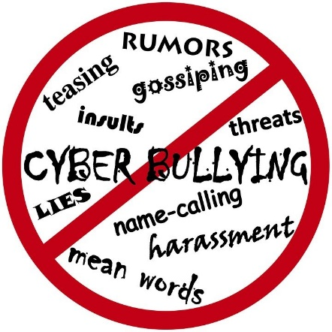
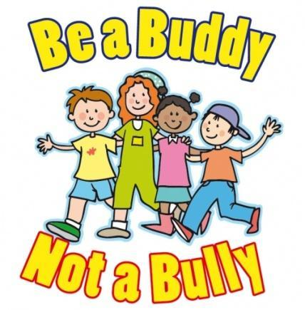
Anti-Bullying Policy
(Child-friendly version)

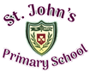

Section 1 – Introduction and Statement

At St John’s bullying is not allowed. Pupils have the right to learn in a safe and happy place.

Section 2 – Context

There is a lot of information on bullying which is law.
Grown-ups have told us how people and children should be treated.

Section 3 - Beliefs and ideas in St John’s

St John’s is a Catholic school with strong values. We like to have rules in our school for better learning. We learn better when we:
*have a school with no bullying
*we believe in a place where bullying is wrong and where every child is safe and is cared for.
*we celebrate our differences
*we want anti- bullying to be in every class in our school.
*respect and look at the discussions of children and young people and look at these views. We will respect and take them into thought.
*understand that everyone in our school has a part to play in taking a stand up to bullying and making a safe and welcoming place for us all.
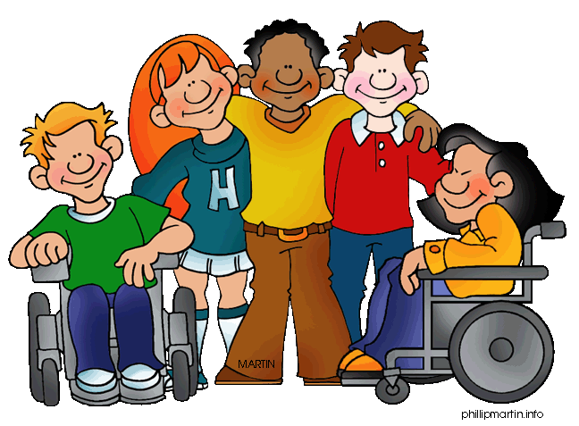

Section 4 – Consultation and Participation

To help make this policy we listened to:
- Class Council
- School workers
- Parents
- Governors

Section 5 – What is Bullying?

Bullying is:
- Being mean to people lots of times
- Calling people names, saying bad things (online also) and writing mean things about people.
- Punching and kicking
- Hurting people mentally
- Bullying is a repeated action, using hurtful words or things like punching or kicking. It can be spoken or written

Bullying is known as repeated actions. Sometimes it can be a one-off.
The school will use these thoughts to decide
- how bad it was
- was it planned
- how did it really hurt the person (physical/emotional)?
- does it affect lots of people?
- were they friends or not?
- were they involved in any other reports?
Our positive behaviour policy will help.

Some types of actions that when done again may turn into bullying:
Verbal or written acts:
- saying mean and hurtful things to, or about, others
- making fun of others
- calling another pupil mean and hurtful names
- telling lies or spread false rumours about others
- try to make other pupils dislike another pupil/s
Physical acts:
- hitting
- kicking
- pushing
- shoving
- material harm, such as taking/stealing money or possessions or causing damage to possessions
Omission (Exclusion)
- leaving someone out of a game
- refusing to include someone in group work
Electronic Arts
- using the internet/phone
- pretending to be someone
- sharing photograph’s or video’s online to embarrass someone

There are lots of ways how bullying could start:
* age * pregnancy
* looks like * marital status
* friends falling out * race
* where you are from * religion
* political affiliation * ability
* family make-up * disability SEN

Bullying can upset people, we must use words to help and support. The words we should use are:
- A child displaying bullying behaviours – not a bully
- A child experiencing bullying behaviours – not a victim

Harm means:
- making someone worry by scaring or embarrassing them
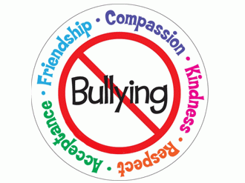
- causing them physical injury

Section 6 – Preventative Measures

How we can stop bullying from happening:
- Tell everyone what way we expect them to behave
- Anti-bullying messages around the school.
- Talking about bullying in class.
- Involvement in meaningful and supportive shared education projects, supporting pupils to explore, understand and respond to difference and diversity.
- Talk about emotional well-being in class.
- Take part in anti-bullying week and other ideas to help.
- Class council and assembles to help support.
- Make playgrounds safe.

Bullying can also take place before or after school. We can stop this happening by reminding everyone of how they should behave, helping our friends, talking to the bus driver and making sure the school helps.

We have to help stop bullying through computers/phones if it is effecting school life. St John’s will talk about online bullying help pupils use internet safely and a responsible way by:
- talking in class and use agencies to help us.
- participating in Anti-Bullying Week activities.
- celebrate safe internet day and keep telling people about internet safety.

Section 7 – Responsibility

In St John’s everyone has responsibility for making sure we are in a safe place to learn. All school staff, parents, guardians are expected to respect the rights of others to be safe.

Everyone has the responsibility to work together to:
- good thoughts about ourselves
- show respect
- look out for bullying behaviour
- tell and adult
- do not get involved in bullying behaviour
- try not to react
- help if safe
- tell the person to tell an adult
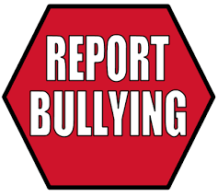
- tell what bullying can lead to
- listen to and help
- teachers can get help from professionals
- help stop bullying

Section 8 - Reporting a Bullying Concern

Pupils report a Concern
In St John’s pupils can talk to Mrs McCullagh, Mrs Kearney, Mrs Coyle or Mrs Blaney or ANY adult, if they have a worry or a concern.

Pupils can report bullying concerns in many ways…
- they can talk to an adult
- they can write a note

Everyone should tell if they see or are bullied.

Parents/Carers Reporting a Concern
Parents should tell their child not to hit back or say/do bad things because this can make things worse.

So what should parents do?
- Parents should tell the teacher and maybe the principal can help.
- The Principal may be able to help.
If parents aren’t happy they can talk to the Board of Governors and they will get back to you.

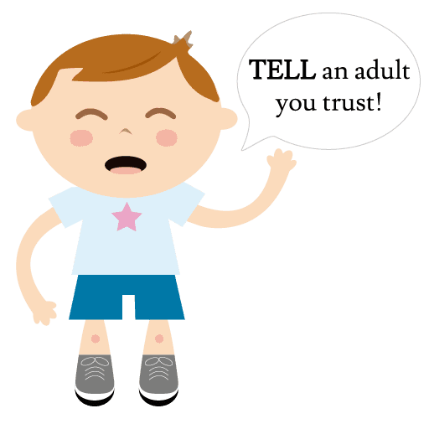
Section 9 – Responding to a Bullying Concern

The member of staff responsible will follow a set rules, they will:

listen carefully, make notes, check -up and help.
Information will be kept confidential, only the pupil and his her parents/carers.

Section 10 – Recording

St. John’s will record and store all the information related to bullying in school.

Section 11 – Professional Development of Staff

In St John’s all staff are trained to help with bullying.

Section 12 – Monitoring and Review of Policy

The Board of Governors and principal will keep checking to make sure this policy is working.

